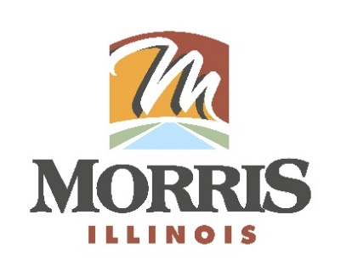
CITY OF MORRIS
700 N. Division Street
Morris, IL 60450
Phone (815) 942-1855
Fax (815) 942-0216
Bill Martin
Building & Zoning Officer
bmartin@morrisil.org
www.morrisil.org

MORRIS PLANNING COMMISSION
AGENDA

TO: JOHN WILKINSON, JIM JENNINGS, BARRY NARVICK, R.H. COLEMAN,
DENNIS HACKETT, JEFF WACHOWSKI, TOM TALARICO, ALDERMAN JULIAN HOUSTON, CITY ATTORNEY GARRETT WHEELER,
CITY PLANNER MIKE HOFFMAN

FROM: BILL MARTIN

DATE: November 12th, 2025

RE: PLANNING COMMISSION MEETING

There will be a meeting of the Morris Planning Commission on November 19th, 2025, at 5:30 p.m. The meeting will be held in the City Council Chambers (ROOM 1107) at the Morris Municipal Services Building, 700 North Division St. in Morris, Illinois.

AGENDA
- Call the meeting to order.
- Attendance is taken.
- The minutes from August 27^{tTH}, 2025, meeting will be reviewed and voted on.
- Motion to withdraw an application filed by The City of Morris Planning Commission to rezone parcel numbers 02-34-278-004, 02-34-277-003, 02-34-277-004, 02-34-278-003, and 02-34-278-002 from M-2 Manufacturing District to LM Light Manufacturing District.
- Planning Commission Recommendation.
- Consider an application from the City of Morris to amend the City of Morris Municipal Code regarding subdivision regulations, site plan review, building codes and vape establishments within the City of Morris.
- Planning Commission Recommendation.
- Audience Participation.
- Close the meeting.

