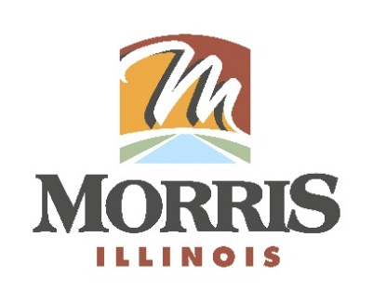
CITY OF MORRIS
700 N. Division Street
Morris, IL 60450
Phone (815) 942-1855
Fax (815) 942-0216
Bill Martin
Building & Zoning Officer
bmartin@morrisil.org
www.morrisil.org

DEVELOPMENT REVIEW COMMITTEE
AGENDA

TO: MAYOR BROWN, CITY PLANNER HOFFMAN, CHIEF OF POLICE STEFFES, FIRE MARSHALL STEFFES, CITY ENGINEER HANSEN, ZONING BOARD OF APPEALS MEMBER TESDAL, MORRIS PLANNING COMMISSIONER NARVICK COUNCIL LIAISON & DRC SECRETARY SMEGO

FROM: BILL MARTIN, BUILDING & ZONING OFFICER

DATE: July 3rd, 2025

RE: DEVELOPMENT REVIEW COMMITTEE MEETING

The MORRIS DEVELOPMENT REVIEW COMMITTEE will meet at 10:00 am, THURSDAY JULY 10TH, 2025. The meeting will be held at the MORRIS MUNICIPAL SERVICES BUILDING City Council Chambers (ROOM 1107). Please contact me if you are unable to attend.

AGENDA
- Call the meeting to order
- Roll Call
- Minutes from The May 8th, 2025, meeting are reviewed and voted on
- QuikTrip and Midwest Design Group to present plans to build a Gas Station on parcel # 02-34-101-010.
- DRC recommendation
- Motion to close the meeting.

