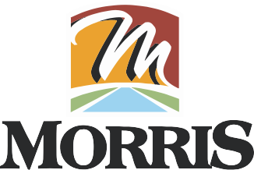

Chris Brown, Mayor Lori Werden, City Clerk Terri Kief, City Treasurer

700 N. Division Street Morris, IL 60450

MEMORANDUM

TO: ALDERMAN HOUSTON
ALDERMAN DUVICK
ALDERMAN HALL

FROM: MAYOR CHRIS BROWN

DATE: June 26th, 2025

RE: WATER & SEWER COMMITTEE MEETING

There will be a meeting of the Water and Sewer Committee on Monday, June 30th, 2025, at 2:15 p.m. The meeting will be held in the Upstairs Conference Room. Please contact me if you are unable to attend.

AGENDA

- Discuss modification to Red Tags
- Discuss Rt. 6 Water Tower contract and RPF

cc: Lori Werden
Garret Wheeler
Chris Dearth

