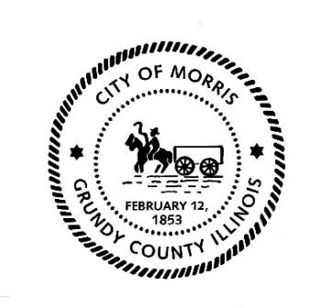
CITY OF MORRIS

700 N. Division Street
Morris, IL 60450
Phone (815) 941-3685
Fax (815) 942-0216
Julie Wilkinson
Business Development Director
jwilkinson@morrisil.org
www.morrisil.org

BUSINESS AND COMMUNITY DEVELOPMENT COMMISSION

TO: STEVE BARR, RAY GROSSI, J.R. HOCK, PATRICK KEEGAN, DAVE RAFFEL, MONICA SCHILD, MICHELLE XYDAKIS, and HERB WYETH

MAYOR BROWN, CITY CLERK LORI WERDEN, TREASURER TERRI KIEF, POLICE CHIEF ALICIA STEFFES, and MIKE HOFFMAN

FROM: JULIE WILKINSON

DATE: January 24th, 2025

RE: BUSINESS AND COMMUNITY DEVELOPMENT COMMISSION MEETING

There will be a meeting of the Business and Community Development Commission on Tuesday, January 28th, 2025, at 10:00AM. The meeting will be held in the City Council Chambers (Room 1107) at the Morris Municipal Services Building, 700 North Division St. in Morris, Illinois.

AGENDA
- Call to order
- Roll Call
- Approval of the October 2024 Meeting Minutes
- Update from Morris Police Department- Chief Alicia Steffes
- Business Development Update – Julie Wilkinson
  - Update on Route 47 lighting
  - Hanging Baskets for Downtown
  - Downtown Events Update- MRA Partnership
  - H.E.R.- Helping Each Other Rise- J.R. Hock
- Introduction to McBride’s Morris
- Audience Participation
- Announcements
  - Galentine’s Day Sip & Shop Event Feb. 8th
  - 2025 City Service Events
- Adjourn

Next meeting date: Tuesday, February 25th at 10:00AM.

